Rotherham Safeguarding Children Partnership
Practice Standards Group
TERMS OF REFERENCE

- Purpose
  - This document sets out the Terms of Reference for the Rotherham Safeguarding Children Partnership (RSCP), Practice Standards Group (‘the Group’). It replaces previous documents entitled Terms of Reference.
- Responsibilities
  - Monitor practice standards across the safeguarding partnership, with reference to:
- Government guidance for information sharing ^{[1]}
- RSCP Procedures and Policies ^{[2]}
- RMBC Practice Standards ^{[3]}
- Statutory Guidance ‘Working Together to Safeguard Children’ ^{[4]}
- National Standards for Youth Justice ^{[4]}
- Standards set out by relevant professional bodies eg:
- Social Work England ^{[5]}
- Nursing and Midwifery Council ^{[6]}
- College of Policing ^{[7]}
- Department for Education ^{[8]}
- National Youth Agency ^{[9]}
  - Facilitate Practice Standards Appraisals (‘Appraisals’) in cases referred to the group where:
- A case or situation is recognised as giving cause for concern in relation to the ways in which Partner Agencies work together to safeguard children, but the criteria for a formal Practice Review are not met: If the Group considers that a case might meet the criteria for Practice Review, the Chair (or other designated member) will discuss it with the Designated Manager (Death or Serious Injury to a Child); or
- A Child Protection Conference Chair has exercised their power of veto regarding a majority decision at Case Conference; either maintaining a child on a Plan or discharging a Plan against the majority view; or
- A child is remanded in custody or Local Authority remand or is handed down a custodial sentence in the court; or
- A Case or situation is recognised for outstanding practice in relation to the ways in which Partner Agencies work together to safeguard children.
  - Undertake enquiries with Partner Agencies as necessary to carry out an Appraisal.
  - Arrange for open and reflective discussions between Professionals involved in an Appraisal, for instance by way of Practitioner Events or other forums.
  - Consider appropriate means of disseminating learning from Appraisals, including training events, whole service events, mentorship, and work-based learning.
  - Provide information about, and advice on disseminating learning from Appraisals, to the RSCP Learning and Improvement Group.
  - Maintain a Group membership that is representative of the statutory and voluntary agencies involved in safeguarding children: Attendance will be monitored in the Minutes of Meetings.

- Membership and Quoracy
  - Membership will consist of named representatives from:
- Education
- Social Care
- Early Help
- Youth Offending Service
- South Yorkshire Police
- The Rotherham NHS Foundation Trust (TRFT)
- Rotherham, Doncaster, and South Humber NHS Foundation Trust (RDaSH)
- Voluntary Sector Agencies
  - The Group will have a Chair and a Deputy Chair, to be nominated and elected by the Group biennially (or at any time by majority decision of the Group), and a permanent Secretary from the RSCP Business Unit.
  - The Group will receive expert advice from a member of the RSCP Business Unit.
  - A named representative who is unable to attend a particular meeting of the Group may nominate a Deputy to attend on their behalf.
  - A meeting of the Group will be considered quorate for decision-making if it is attended by at least three of the named representatives, including a representative from Children’s Social Care and a representative from one of the NHS Trusts. Specific decisions may only be made if the Group is quorate, and there is a representative present from each of the agencies concerned with the decision.
  - The Group may request attendance at a meeting or participation in an Appraisal by professionals from any Agency.
  - Any Agency that is not normally represented may request an invitation to attend a meeting, or participate in an Appraisal, which will be given due consideration by the Group.
- Administration
  - Meetings will be held bi-monthly. Each meeting will last for no longer than 90 minutes and will usually be conducted via an online platform.
  - An Annual Review meeting will be held each October or November, depending on which month the meeting falls into, when the Terms of reference will be reviewed and updated, the past year’s Appraisals and other activities reviewed, and a brief Annual Report prepared to present to the Learning & Improvement Subgroup. The Annual Review meeting will last for no longer than 90 minutes.
  - The Agenda for each meeting will be proposed by the Secretary and agreed with the Chair prior to publication. Any member of the Group may put an item forward for the Agenda.
Documents for each meeting will be circulated to the named representatives at least five working days before the meeting.
  - Minutes from meetings will be circulated to the named representatives within ten working days following the meeting.
  - Each Appraisal will be conducted by a small group of nominated representatives from the Agencies involved in the case or situation, led by the Chair of the Group or another nominated representative, who will report back to the next meeting of the Group.
  - Case Conference Chair Veto Appraisals will be conducted by means of the Case Conference Chair’s request being circulated to each named representative, seeking their opinion on whether the veto should be upheld or not. Each representative will submit their view within two weeks. The consensus will then be considered and fed back to the Case Conference Chair by the Group Chair, with circulation to the Manager of Case Conference Chairs, and the Head of Service for Children’s Services. If there is no consensus the Chair will feed back the majority viewpoint.
  - General Administration will be provided by the permanent Secretary from the RSCP Business Unit.

- Declaration of interest
  - It is the responsibility of each member to declare any conflict of interest with any Agenda item, either at the start of the meeting or as the discussion unfolds.

- Business Conduct
  - All meetings will Start and end on time as agreed.
  - The Chair and each representative will respect and value the contribution of all present and encourage the participation of all members.
  - Work plans and specified Actions will be developed and progressed through the meetings.

- Governance Arrangements
  - The Practice Standards Group is a sub-group of the RSCP Learning and Improvement Delivery Group, and work will be undertaken on behalf of RSCP. Regular updates will be provided to the RSCP Learning and Improvement Delivery Group by the Chair of the Practice Standards Group, or a nominated Deputy, attending meetings of the Delivery Group.
  - The Terms of Reference will be agreed by the Chair and Group Members and reviewed annually. Once agreed the Terms of Reference will be ratified by RSCP.
  - Minutes of meetings, Appraisals and outcomes are open for scrutiny by the RSCP.

- References:
[1] Information Sharing: https://assets.publishing.service.gov.uk/government/uploads/system/uploads/attachment_data/file/721581/Information_sharing_advice_practitioners_safeguarding_services.pdf
[2] RSCP Policies and Procedures: https://rotherhamscb.proceduresonline.com/
[3] RMBC Practice Standards: https://www.rotherham.gov.uk/council-vacancies/childrens-social-work-jobs/5
[4] Working Together to Safeguard Children: https://www.gov.uk/government/publications/working-together-to-safeguard-children--2
[5] National Standards for Youth Justice: https://www.gov.uk/government/publications/national-standards-for-youth-justice-services
[6] Social Work England: https://www.socialworkengland.org.uk/standards/professional-standards/
[7] Nursing and Midwifery Council: https://www.nmc.org.uk/standards/code/
[8] College of Policing: https://www.app.college.police.uk/app-content/professional-standards/
[9] Department for Education: https://www.gov.uk/government/publications/teachers-standards
[10] National Youth Agency: https://nya.org.uk/2020/05/national-occupational-standards-and-english-youth-work-policy-new-document-published/

Date Review Completed | 15/11/2022
Chair of the Group at the time of Review | Malcolm Ewing
Date of previous Review | 01/11/2021
Next Review due date | 01/11/2023

APPENDIX – Referral Form

Practice Standards Group Referral

Criteria for Practice Standards Group Appraisal

The Practice Standards Group will conduct an Appraisal where:
- A case or situation is recognised as giving cause for concern in relation to the ways in which Partner Agencies work together to safeguard children, but the criteria for a formal Practice Review are not met; or
- A Child Protection Conference Chair has exercised their power of veto regarding a majority decision at Case Conference; either maintaining a child on a Plan or discharging a Plan against the majority view; or
- A Case or situation is recognised as outstanding in relation to the ways in which Partner Agencies work together to safeguard children.

A Practice Standards Group Appraisal is not for:
- Settling disputes that could be resolved more appropriately elsewhere; or
- Raising concerns about another agency, where it would be appropriate to use internal or cross agency escalation procedures for the Practice Resolution Protocol: Resolving Professional Differences of Opinion; or
- Raising concerns about an individual’s practice. You should use your Agency’s procedures or refer to the relevant professional body.

We adopt the Rotherham Family Approach:

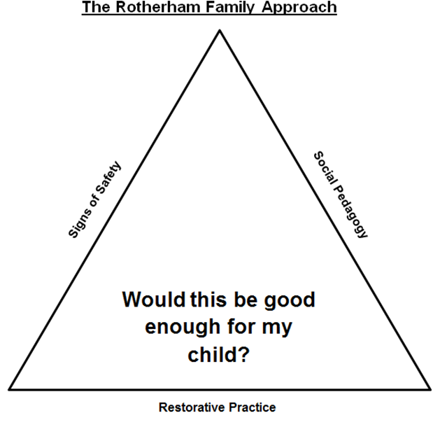
PART 1: Background Information

Is this a Veto by a Child Protection Conference Chair? | Yes/No
Has this case been subject to the Practice Resolution Protocol, escalation, or challenge within or between organisations or services? | Yes/No

Child(ren)’s Name(s) |  | DoB(s)
Carer’s Name(s) | Parental  Responsibility? | DoB(s)
Address:

Brief background to family circumstances:

Referrer

Name | Job Role & Agency | Contact Information  (Telephone, email, address)

Date of Referral:

Part 2: Veto by a Child Protection Conference Chair

Date of Conference
Initial Review Insert X

Reason for Conference
Outcome and Rationale
Reason for Veto

Part 3: A case or situation is recognised as giving cause for concern, or as outstanding in relation to the ways in which Partner Agencies work together to safeguard children

Cause for Concern Outstanding Practice Insert X

Description of circumstances or events giving rise to this Referral
What is your interpretation of the child’s view (voice of the child)?

