Practice Standards Group Referral

Criteria for Practice Standards Group Appraisal

The Practice Standards Group will conduct an Appraisal where:
- A case or situation is recognised as giving cause for concern in relation to the ways in which Partner Agencies work together to safeguard children, but the criteria for a formal Practice Review are not met; or
- A Child Protection Conference Chair has exercised their power of veto regarding a majority decision at Case Conference; either maintaining a child on a Plan or discharging a Plan against the majority view; or
- A Case or situation is recognised as exemplary in relation to the ways in which Partner Agencies work together to safeguard children.

A Practice Standards Group Appraisal is not for:
- Settling disputes that could be resolved more appropriately elsewhere; or
- Raising concerns about another agency, where it would be appropriate to use internal or cross agency escalation procedures for the Practice Resolution Protocol: Resolving Professional Differences of Opinion; or
- Raising concerns about an individual’s practice. You should use your Agency’s procedures or refer to the relevant professional body.

We adopt the Rotherham Family Approach:

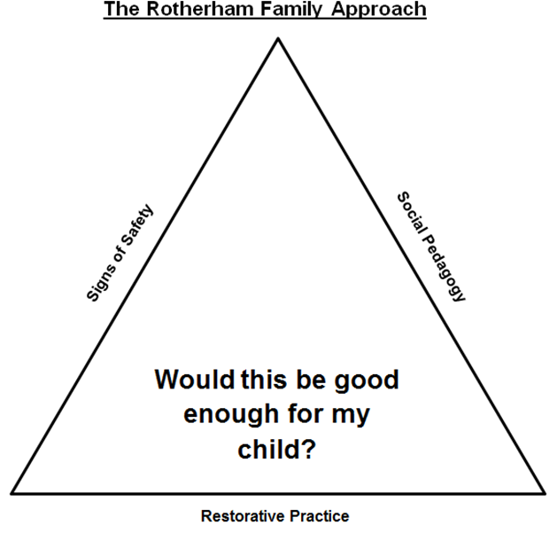

PART 1: Background Information

Is this a Veto by a Child Protection Conference Chair? | Yes/No
Has this case been subject to the Practice Resolution Protocol, escalation, or challenge within or between organisations or services? | Yes/No

Child(ren)’s Name(s) |  | DoB(s)
Carer’s Name(s) | Parental  Responsibility? | DoB(s)
Address:

Referrer

Name | Job Role & Agency | Contact Information  (Telephone, email, address)

Date of Referral:

Part 2: Veto by a Child Protection Conference Chair

Date of Conference
Initial Review Insert X

Reason for Conference
Outcome and Rationale
Reason for Veto

Part 3: A case or situation is recognised as giving cause for concern, or as exemplary
in relation to the ways in which Partner Agencies work together to safeguard children

Cause for Concern Exemplary Practice Insert X

Description of circumstances or events giving rise to this Referral
What is your interpretation of the child’s view (voice of the child)?

Agencies and Professionals Involved

Names | Job Roles & Agencies | Contact Information

Purpose of Appraisal

What are the issues relating working together to safeguard children in this case?

What are the potential areas of learning in this case?

And Finally
Please submit this Form to the Rotherham Safeguarding Children Partnership at:
RSCP@rotherham.gov.uk (this is a secure email address)

