**Child Death**

**e-CDOP**

**Reporting Forms**



**Useful Contacts**

* Rotherham CDOP Administrator – Alex Roberts 01709 808076

[Alex.Roberts@rotherham.gov.uk](mailto:Alex.Roberts@rotherham.gov.uk)

* TRFT Child Death Admin Support

Ellie Freer 01709 424233

[Ellie.freer@nhs.net](mailto:Ellie.freer@nhs.net)

* Lead Nurse Child Death Review – Sharon Pagdin 07717 800 738

[Sharon.pagdin@nhs.net](mailto:Sharon.pagdin@nhs.net)

**Background -** Following the death of an infant/child and regardless of if the death was expected or unexpected, essential information is gathered from all professionals involved in care given during the infant/child’s life and death. Rotherham Safeguarding Children Partnership use an electronic system to gather such information. The following points may be helpful to you, should you receive a request for information.

1. BACKGROUND

**Sharing information** – Section 16 M-N of the Children Act 2004 makes provision for any information to be shared for the purpose of understanding and learning from child death. Under this Act, professionals can safely and legally share information requested by CDOP without needing consent from the family. This includes information on parents and details of mother’s pregnancy, which may be important factors in the child’s vulnerability, ill health or death.

**Additional Information**

* Check out the supporting guidance documents sent out with your e-CDOP request for information, they’

explain what is needed in your report.

* National Child Mortality Database [www.ncmd.info](http://www.ncmd.info)
* NCMD How to complete and effective reporting form [NCMD in the COVID-19 pandemic (pcdn.co)](https://s42140.pcdn.co/wp-content/uploads/How-to-complete-an-effective-reporting-form_21st-Sept-2021.pdf)

**You have legal requirement to complete a request for information following an infant/child death** regardless of cause of death or when/if they last accessed your service, (Children Act 2004, Children and Social Work Act 2017 and Working Together to Safeguard Children Chapter 5, 2018.

**Neonatal deaths** require information about maternal health and care during pregnancy, even if you did not know the infant.

**Rotherham Child Death Overview Panel** (CDOP) makes the request for information via electronic e-CDOP system. We cannot accept your system print- outs.

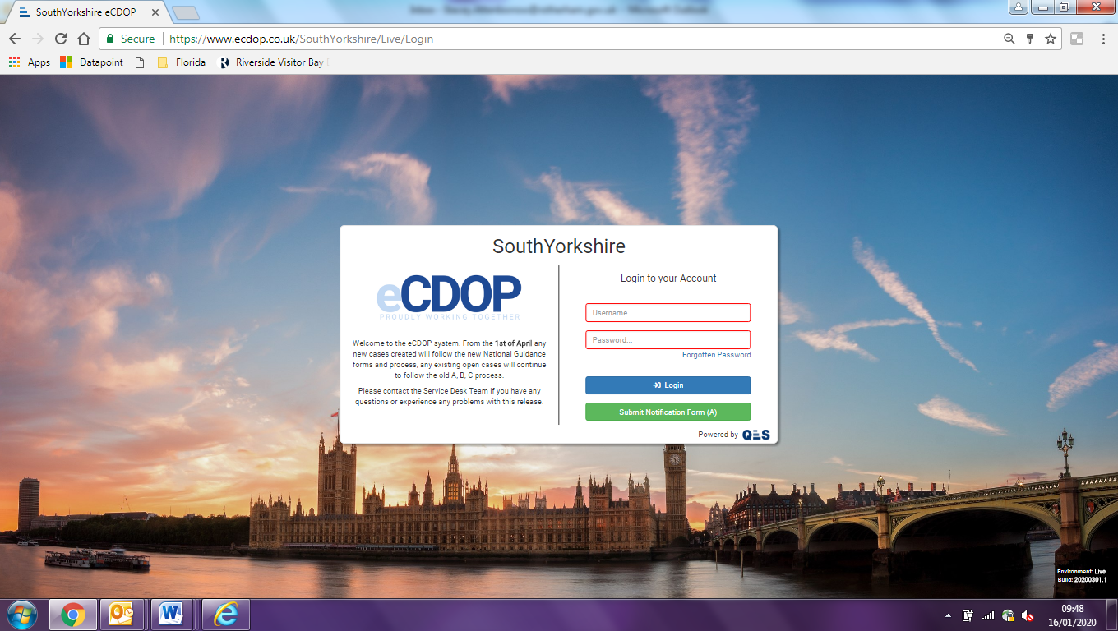

Information relating to siblings of a deceased child is requested via email word document.