# **Rotherham Safeguarding Children Partnership logo with a circular graphic representing two people holding a child**

# **7 Secrets to having happy children ...**

**RSCP Annual Report 2023-24**

Contents

|  |  |
| --- | --- |
| Page | Content |
| 3 | Introduction |
| 5 | RSCP principles |
| 6 | Chair’s Foreword |
| 8 | Welcome to Rotherham |
| 11 | Exploring Child Protection Plans and Looked After Children |
| 13 | Governance |
| 15 | RSCP Structure |
| 16 | Funding Arrangements |
| 17 | Strategic Priorities and Activity of the delivery groups |
| 27 | Appendix - Plan on a Page 2024/2025 |

# **Section 1**

**Introduction**

Welcome to the annual assurance report from the Rotherham Safeguarding Children partnership (RSCP) for the year 2023-2024. This annual report pulls together then key activity of the RSCP within the last year and the assurance gained in relation to the safety of children in the Rotherham area. In line with statutory guidance (Working together to Safeguard children 2023), it should cover:

* What the partnership has done as a result of the arrangements, including child safeguarding practice reviews, and
* How effective these arrangements have been in practice.

In addition, the report should also include:

* + The contribution of each safeguarding partner to the multi-agency safeguarding arrangements
  + Any themes identified from scrutiny and audit processes
  + Evidence the impact of the work of the safeguarding partners and relevant agencies
  + Analysis of areas where there has been little or no evidence of progress on agreed priorities
  + Analysis of learning from serious incidents
  + Key decisions and actions taken by the safeguarding partners in the yearly cycle
  + How safeguarding partners have sought and utilised feedback from children and families
  + Financial arrangements for the period
  + How safeguarding partners ensure adequate representation and education at both operational and strategic levels
  + How data is being used to encourage learning, and how information sharing has improved practice
  + The learning identified from independent scrutiny
  + Any updates to the published arrangements
  + Evidence that national reforms have been implemented.

The RSCP priorities have been renewed for 2023-24 and are themed under three key delivery objectives:

* **Child Exploitation**
* **Neglect**
* **Safeguarding in Education**

The above priorities were also informed by the key principles below, which underpinned all activity undertaken by the RSCP to safeguard and promote the welfare of children in Rotherham:

* **Safe at Home**
* **Safe in the Community**
* **Safe Safeguarding Systems**

The Safeguarding Partners for the 2023-2024 year were:

**Chris Edwards**, Chief Officer, NHS Rotherham Integrated Care Board.

**Sharon Kemp**, Chief Executive, Rotherham Metropolitan Borough Council

**Sarah Poolman**, Deputy Chief Constable, South Yorkshire Police

RSCP Principles

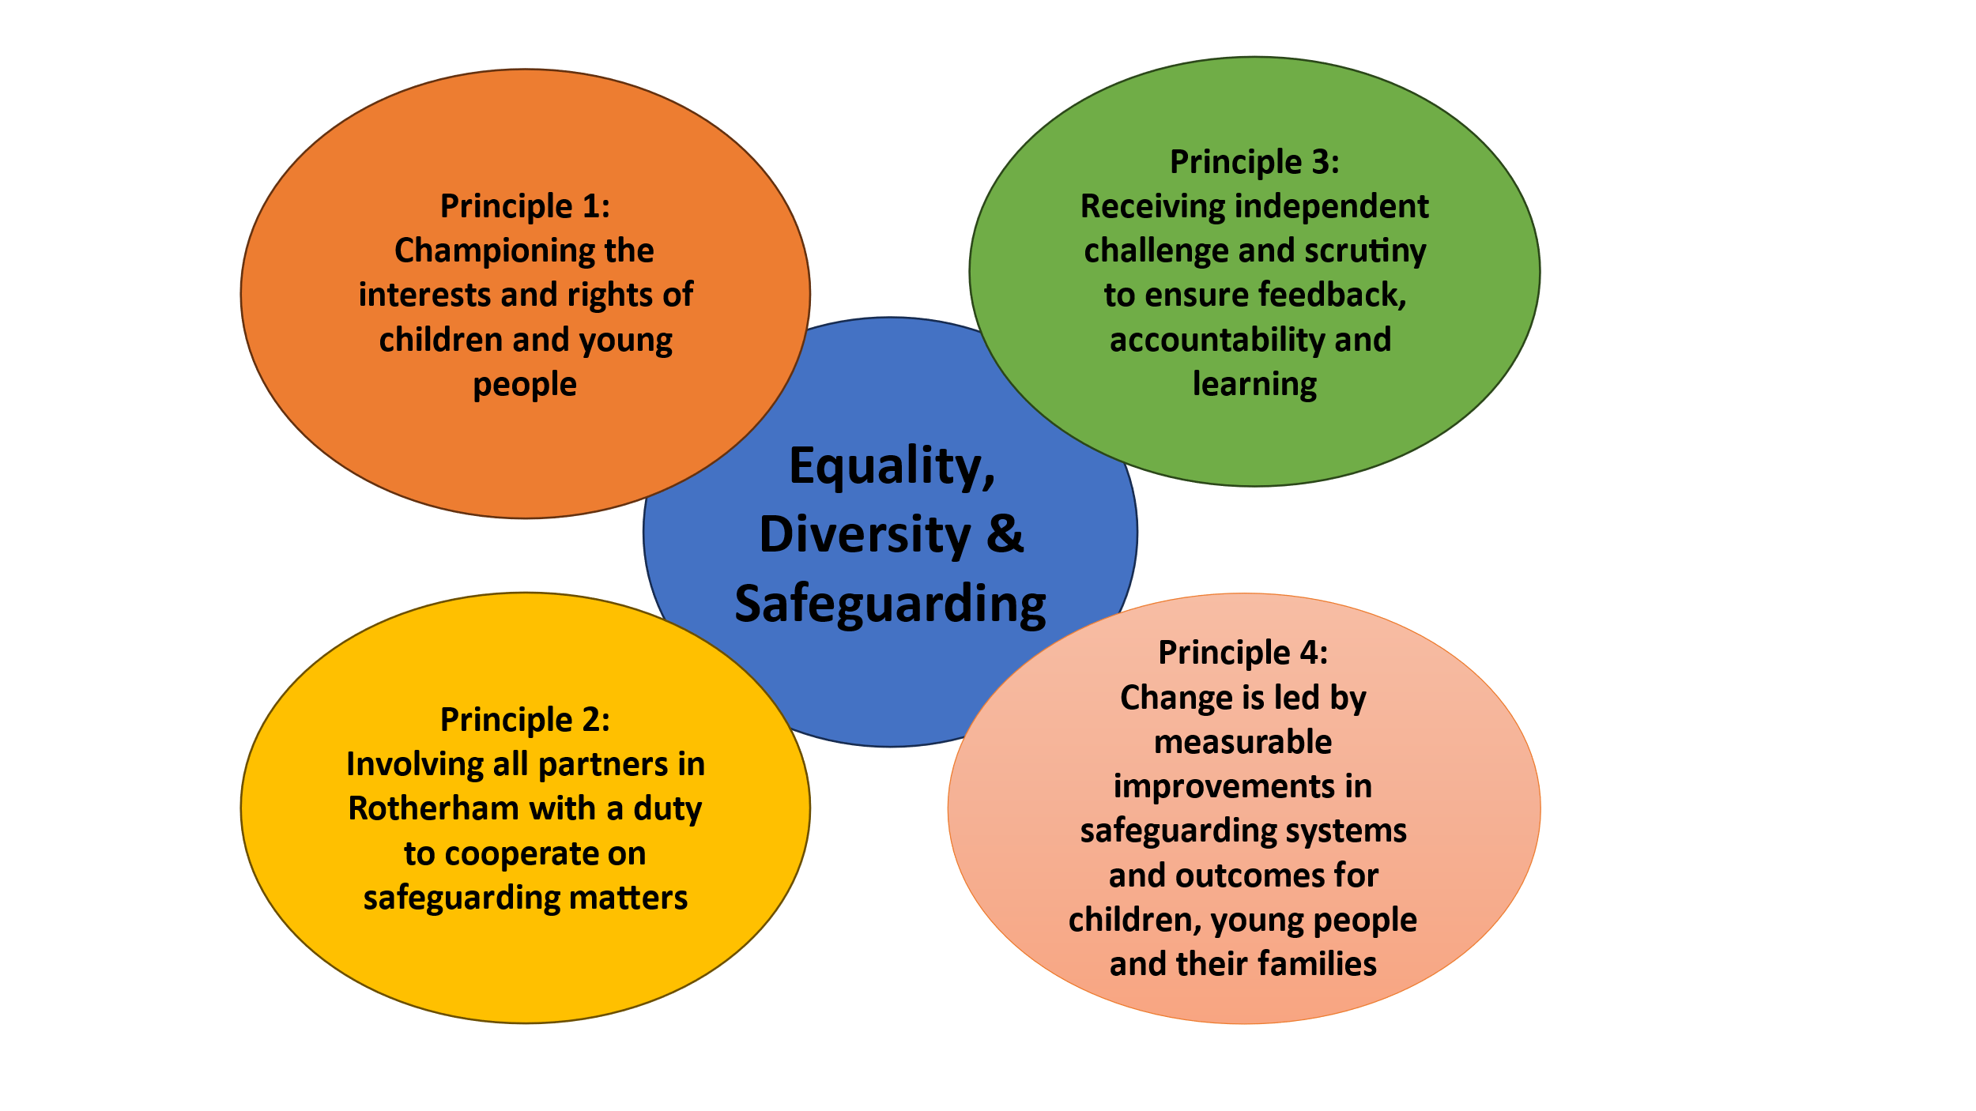

**Foreword from the RSCP Independent Chair – Darren Downs**

It is a great pleasure to not only contribute to the Rotherham Safeguarding Children Partnership (RSCP) annual report but to also be the independent chair and scrutineer of the partnership, taking on the role in early 2023, and I look forward to continuing to provide reassurance and scrutiny over the coming years.

The Annual Report 2023-24 reflects our commitment and achievements, as well as identifies areas where we need to continue to make improvements to ensure we meet the overarching principles of being Safe at Home, Safe in the Community and having Safe Safeguarding systems. I continue to be impressed by the strength and level of engagement across the partnership and the commitment and passion to safeguard our children and give them the best start in life.

The partnership has had some new members in the last year, and it is an ideal opportunity to thank those that have left the partnership, for their work and commitment in recent years in helping us achieve the position we are in now in. The year has seen a number of audits and inspections building on the previous HMICFRS and OFSTED inspections, these continue to identify that safeguarding activity is good across the partnership. This is something we will continue to build on in the coming year to ensure the services we deliver are the best they can be.

Rotherham has a large proportion of its population between 0-19 years of age, with 23.2% of people falling into that category, and a large proportion below the age of 15. The concentration of children varies across the borough with some areas seeing a quarter of their population aged below 15, which presents some challenges. The number of children subject to a Child Protection Plan (CPP) was 265 at the year end, which is a significant reduction from 396 at the same point in 2023 and a really positive sign that we are identifying risk at an earlier stage, and intervening to reduce this risk before it comes of greater concern. The vast majority of the CPPs relate to emotional abuse, followed by neglect, and provide good evidence of the reasons for continued collaboration between the statutory boards and in particular the Rotherham Safer Partnership.

One area where further work is needed is in addressing the disproportionate level of children from our minority communities on CP plans and cared for by the partnership. The communities of Rotherham continue to change, and it is important that as a partnership we ensure no community is disadvantaged and that all children have the best start in life.

As we move into the next year and plans are refreshed for the future years, I look forward to continuing to push the partnership to make positive improvements and to ensure that all children on Rotherham have a positive and safe foundation to build upon. Many of the previous projects and improvements such as EVOLVE, MASH, and MACE will all continue, and we look to strengthen services further with a focus on neglect and safeguarding in education.

It is key that we continue to celebrate and promote the good work that is taking place and improve the relationships and visibility we have with communities and partners, including our active voluntary sector. This will be a key area of focus for the partnership, and I will update you in the next annual report around the progress we make in this area.

**Section 2**

**Welcome to Rotherham**



Rotherham is a large minster town in South Yorkshire, England which along with its nearby settlements form the Metropolitan Borough of Rotherham, with a population of 265,800 (ONS, 2021).

In Rotherham there are 61,600 0–19-year-old children living in the Borough (23.1% of the local population – ONS, 2021). There has been a significant increase in the Eastern European Roma population (from Slovakia and Czech Republic since 2004 and Romania since 2014), concentrated in a few central neighbourhoods (Boston Castle, Rotherham East, and Rotherham West). The Borough is divided into 21 wards covering a wide diversity of urban, suburban and rural areas, covering an area of 110 square miles.

Whilst the majority of children get a good start in life, child poverty is highly polarised across the Borough and life chances can vary greatly. In the most deprived areas, 25% of the population are aged 0-15, but in the least deprived, the proportion is only 16%. Rotherham has a lower proportion of young people aged 18-24 than the national average due to young people moving elsewhere to study or work.

**Key Demographics**

Further local and national demographics information tells us that: -

* 23% of children living in Rotherham are in low-income families (England 20% - 2022).
* Our Free School Meal (FSM) entitlement rate is above national average, 25.2% compared to 23.1% at Primary phase and 24.1% compared to 20.9% at Secondary phase (DfE 2021/22).
* According to the 2019 Indices of Deprivation, deprivation in Rotherham has **increased** with the Borough now ranked **44th** most deprived district on average IMD score, compared to 52nd in 2015. Rotherham’s rank means that the Borough is amongst the 14% most deprived local authority areas in England.
* In 2019, the key drivers of deprivation in Rotherham remained **Health & Disability**, **Education & Skills,** and **Employment**. Of these, Health & Disability deprivation was most severe and widespread whilst Employment and Education deprivation were more concentrated and polarised. Health and Crime deprivation have increased the most since 2015 according to the Indices.
* 20.1% of our school age population is from Black and Minority Ethnic background (BME) (England 36.1%) (DfE 2021/22)
* Disability Living Allowance (DLA) is claimed for 7.7% of children aged under 16 years in the local authority area compared with 5.3% in England as a whole
* In the borough 549 children were recorded as receiving Elective Home Education (EHE) at the year-end 2023/24
* School OFSTED ratings in the borough are as follows: Outstanding = 16 schools, Good = 77 schools, Requires Improvement = 16 schools, Inadequate = 4 schools
* 8056 Children and Young People identified for SEN Support covering Reception to Y11 as at end of March 2024
* At the time of writing this report 179 young people were not in Education, Employment or training (NEET)
* At the end of March 2024, 616 fixed exclusions were in place for secondary schools, with 10 permanent exclusions. 59 fixed exclusions were in place for primary schools with 1 permanent exclusion.
* 3360 children had an Education Health Care Plan (EHCP) at the end of 2023-24
* 503 children were in Local Authority care as at 31 March 2024

**Equality and Diversity**

The RSCP is mindful of the representation of children from minority backgrounds within statutory processes, and will be launching an equality, inclusion, diversity and belonging strategy over the next 3-year period. It is evident that those from minority backgrounds are overrepresented in or Child Protection (CP) plans and in our Care, with children from non-white backgrounds representing 23% of those subject to a CP plan and 30% of children in care. As a further example, children from a Gypsy/Roma background constituted 5.5.% of those on CP plans and 8.1% of children in care compared to a population of 0.049% in the borough.

**Exploring Child Protection Plans and Looked After Children**

|  |  |  |  |  |  |  |
| --- | --- | --- | --- | --- | --- | --- |
|  | **2022-23** | | | **2023-24** | | |
|  | **Rotherham** | **Statistical Neighbour Average** | **National Average** | **Rotherham** | **Statistical Neighbour Average** | **National Average** |
| **No of children subject of CP plans (per 10,000)** | **70.4 (82.7)** | **59.2** | **42.1** | **45.6** | **60.0** | **43.2** |
| **No of children looked after (per 10,000)** | **96.2 (97.8)** | **102.4** | **70.0** | **87.7** | **103.1** | **81.8** |

As can be seen, there has been a significant reduction in the numbers of children subject of CP planning over the course of the year, following a consistent downward trend in preceding years. From a high within year of 434 children in June 2023, there were 265 children subject to a CP plan as at 31 March 2024 in the following categories:

|  |  |  |  |
| --- | --- | --- | --- |
| **2022-23** | | **2023-24** | |
| **Category of Abuse** | **No. of children** | **Category of Abuse** | **No. of children** |
| Emotional | 210 | Emotional | 115 |
| Neglect | 141 | Neglect | 126 |
| Physical | 25 | Physical | 16 |
| Sexual/Multiple | 18/2 | Sexual | 8 |
| **Total** | **396** | **Total** | **265** |

Alongside the overall reduction in CP numbers, there has been a significant decrease in the amount of children subject to CP plans for emotional harm this year, the largest category now being that of Neglect.

Whilst detailed analysis is yet to take place, it is acknowledged the category of emotional harm is most often linked to situations of domestic abuse and there is some potential that numbers have reduced as a consequence of the following practices:

* Children that were subject to plans for a prolonged period exiting the CP process
* Domestic abuse being managed within Child in Need processes, with safety planning taking place within this arena
* A decline in CP requests from the front door/MASH service at the point of initial concern
* The impact, further downstream, of the Reducing Parental Conflict intervention, an Early Help initiative
* There has also been a fairly high reduction in the number of CP conferences undertaken within 2023-24, with 271 in the first half of the year compared to 157 in the second half.

As a result of these findings the safeguarding partnership will look to reassure themselves that children are receiving the appropriate level of intervention. This will be part of the scrutiny process in 2024-25 and will be overseen via the Practice Performance and Learning (PPL) delivery group.

In relation to children in care, rates have remained consistent at around 500 children in care for the year. This equates to 87.7 children per 10,000 at the close of 2023-24, the national average being 71 and the statistical neighbour average being 101 children, and an area of continued work for the next year.

**Section 3**

**Governance and Structure of the RSCP**

The RSCP was established in September 2019 in accordance with the Children’s Act 2004 (as amended by the Children and Social Work Act 2017) and Working Together to Safeguard Children 2019 (WT19).

The new legislation enshrined in Working Together 2023 (WT23) has reaffirmed the role of the three statutory safeguarding partners, and has further defined the remit of chief officers, leaders and managers within the governance. The partnership is reviewing the safeguarding arrangements in line with the WT23 guidance during the current year and will ensure that we continue to meet expectations and protect our communities. It is not anticipated that governance structures will alter at this point.

The Executive Group continues to set the strategic direction and priorities of the Partnership. The priorities are aligned with those of the other key partnership boards; Health & Wellbeing, Rotherham Safer Partnership and the Safeguarding Adults Board. The three main statutory partners, Rotherham Council, South Yorkshire Police and South Yorkshire ICB continue to work collaboratively with the wider partnership and Voluntary Consortium to deliver a safer Rotherham. The partnership continues to demonstrate a commitment to ensuring the voice of children and young people is at the heart of the safeguarding agenda in Rotherham.

Rotherham Safeguarding Children Partnership has renewed the Delivery Groups alongside the strategic priorities for 2023-2026. This is in response to emerging themes in the education safeguarding arena and a wish to continue to promote and develop the role education plays within children’s safeguarding. In addition, a delivery group focusing solely on Neglect has been created. This is in recognition of the complex and challenging context that exists around neglect and a steadfast commitment from the RSCP to address and reduce the impact of neglect on Rotherham’s children. The Practice Performance and Learning (PPL) delivery group has taken on the areas of quality assurance, training and learning from practice. This includes the oversight and management of all safeguarding practice reviews. The Child Exploitation Delivery Group (CEDG) has remained and is focussed on the exploitation of children and young people and delivery of the new Child Exploitation Strategy. The partnership has maintained strong links with the Child Death Overview Panel (CDOP) throughout 2023/24.

The delivery groups have a nominated chair and representatives from across the different multi-agencies that make up the partnership, ensuring everyone has accountability in the partnership, and that accountability and challenge is maximised. These groups meet every two months and progress activity reporting progress into the bi-monthly Executive Board, providing reassurance on activity to executive members, and having their work scrutinised. The details of all the priorities and membership is contained in the local Multi-Agency Safeguarding Arrangements (MASA) which is being updated in line with Working Together to Safeguard Children 2023 guidance. The Child Death Overview Panel (CDOP) reports into the RSCP on any issues that have safeguarding concerns identified within them and provides a copy of their annual report.

**RSCP Structure**

**Funding Arrangements**

The RSCP funding is provided by the three main statutory agencies, with a small contribution from Probation. Management and oversight for budget spend is provided through the Partnership Executive Group.

|  |  |
| --- | --- |
| **Rotherham Safeguarding Children Partnership Funding** |  |
| **Rotherham Council** | **£115,352** |
| **NHS Rotherham Clinical Commissioning Group** | **£115,352** |
| **South Yorkshire Police** | **£44,475** |
| **Probation** | **£2048** |
| **Total Budget** | **£277,227** |

**Section 4**

**Strategic Priorities and Activity of the delivery groups**

1. **Practice Performance and Learning Delivery Group (PPL)**

**Case Reviews**

During 2023-24 the RSCP has convened 1 rapid review, in November 2023, after a notification was made to the National Panel. The outcome was to convene a multi-agency local review, coordinated by the business manager, which would be overseen within the PPL delivery group. This is still in progress and due to conclude in October 2024.

At present there is one Safeguarding Practice Review (SPR) being undertaken, which will report late in 2024. This is being completed by an independent author, overseen directly by the Executive Group, and the National Panel will be updated once the review report is available.

The decision to notify the National Panel rests with the Local Authority and with input from the senior representatives of the three safeguarding partners, and meetings to make this decision are convened on a case-by-case basis and decisions recorded by the PPL group. Rapid reviews are held for all children notified and may also be held if partners feel there is potential learning for the partnership from the scoping. To date in addition to the above, four children have been the subject of partnership discussion, none progressing to notification or rapid review due to the criteria not being met.

**Audit**

The RSCP has completed 5 audits during the year covering the following themes:

* Early Help,
* Care leavers (Transitions and Exploitation),
* Persistent School absence,
* Early Help – JTAI related,
* Persistent Youth Violence.

Partners completed comprehensive audits, looking into individual children’s records, sharing information and findings to understand practice, both good and areas for improvement. The findings have been communicated across the partnership, including a full report and seven-minute briefing. Colleagues across the partnership have worked well with challenge and scrutiny to evidence that children were safe, their experiences were understood and that learning for future practice and training has been identified.Alongside quantitative analysis a total of 23 deep dive audits were completed and judged as follows:

* 1 Outstanding,
* 17 Good,
* 5 Requires Improvement.

There were no children identified that were felt to be in unsafe situations.

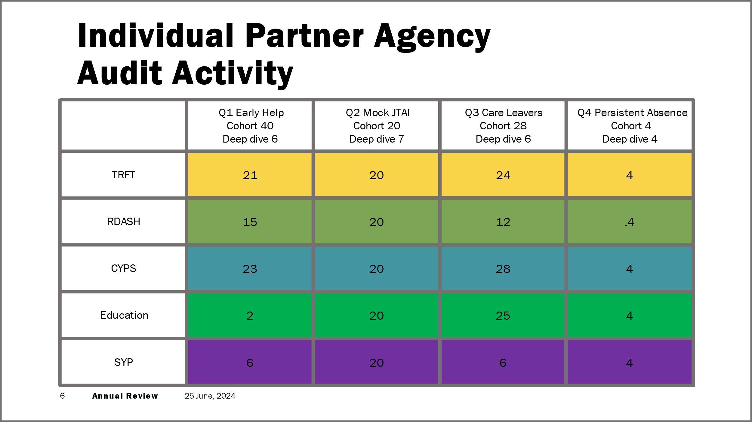

Learning for practice was identified in the following areas and has informed the learning and development action plan for 2024-25, which will be delivered by the PPL group and monitored by the Executive.

* Practitioners need to continue to explicitly describe and evidence the impact of neurodiversity and intersectionality for our children. A review of Pathway Plans for care leavers is underway to improve detail and quality to assure they are strengths based, restorative and aspirational.
* Relevant Information Sharing between regional Police Forces and Health Authorities needs to be improved.
* Consistent review and challenge processes to be developed for Alternative Education Provision, where this is not seen to improve outcomes for the child.
* The routine, consistent and robust completion of Graded Care profile 2 (GCP2) and case mapping needs to be further embedded and evidenced in records. History and involvement should be considered holistically at all transition and transfer points within the system.

The RSCP audit consultant is responsible for compiling action plans from each audit conducted, and with the oversight of PPL will follow up on these action plans to ensure they are delivered, and that reassurance is provided to partners and that practice improves. This is then scrutinised by the Executive to ensure progress is made against the learning.

Audits have been identified for 2024-25 by the Executive having been influenced by the findings from this year’s audits and areas of focus. The outstanding audit for the year will focus on any emerging issues or themes. The three audits identified are as follows:

**Quarter 1 -** Neglect and use of GCP2 for children subject to child protection planning

**Quarter 2 -** Elective Home Educationand information sharing

**Quarter 3 -** Domestic Abuse and Children (JTAI theme)

**Quarter 4 -** Child Exploitation and unconscious bias (tbc)

**Training and Learning**

The RSCP has continued to provide a core offer of training for colleagues in 2023-24. In this time 975 staff have attended courses as detailed in the table below

|  |  |  |
| --- | --- | --- |
| **Course** | **Sessions** | **Staff attended** |
| **Child Exploitation and Contextual Safeguarding** | **1** | **44** |
| **Cumulative Harm and Child Neglect** | **1** | **59** |
| **Designated Safeguarding Leads/Education Safeguarding Forum** | **4** | **191** |
| **Striving Towards Trauma Informed services** | **1** | **6** |
| **Safer Recruitment** | **Online** | **214** |
| **LADO and Allegations Management** | **3** | **70** |
| **Level 3 Safeguarding Children** | **4** | **123** |
| **Recognising and Responding to Children who Display Sexually Harmful Behaviour** | **1** | **34** |
| **Safer Sleep** | **2** | **19** |
| **Unconscious Bias in Child suffering Child Exploitation (Mar/Apr 2024)** | **12** | **215** |
| **Totals** | **29** | **975** |

In November 2023, the RSCP held the Safeguarding Awareness Week in conjunction with Rotherham Safeguarding Adults Board (RSAB). The main themes covered was online abuse, and over 100 colleagues and senior leaders attended both a local and regional launch of the awareness week. Professionals attending stated that they benefitted from the following aspects of the launch events.

* Use of real examples and situations
* Networking opportunity
* South Yorkshire Police Fraud Awareness
* Real Safeguarding Stories
* Really informative and should be shared wider to assist staff
* A session on online fraud prevention

Over the course of the week, 17 further sessions were delivered to colleagues, and covered themes such as extremism, current and emerging risk, and an introduction to parent advocacy.

The “Be The One” suicide prevention awareness session was also well attended with in excess of 500 people attending virtually and face to face from the region.

**Procedures**

The RSCP receives twice yearly updates via the Tri-X online procedures system. This system, aside from changes to national legislation, allows for the update of local guidance. In 2023-24 updates were completed for the following areas

* Dangerous Dogs
* Sudden Traumatic Bereavement pathway
* Prevention of homelessness and provision of accommodation for 16- and 17-year-old young people, who may be homeless and/or require accommodation

1. **Child Exploitation Delivery Group (CEDG)**

The RSCP’s child exploitation offer is well established and long running. During 2023-24, the delivery group has been progressing the CEDG 2023-28 Workplan which contains the activity required to deliver the priorities of the CE strategy. The work focusses on the four pillars of Prepare, Prevent, Protect and Pursue, with activity against all four being coordinated across the partnership, each agency playing their role. The group is supported by the CE Strategy which seeks to enhance our work in the field of contextual safeguarding, ensuring that our processes, policies and responses to children are equipped to deal with risk outside the home.

**Achievements**

**Preparation**

* The Evolve Team has continued to work directly with young people affected by child exploitation. They contribute to assessments, investigations, mapping activity, collating information, and analysing the prevalence of child exploitation in the Borough, in relation to children and young people, perpetrators, and locations. The team has also supported professionals and partners such as schools, through providing guidance, advice, and a comprehensive RSCP training package.
* The voice of the service user continues to be captured through many feedback processes. When a child or young person leaves the Evolve Service, a feedback session is undertaken to discuss the activities completed, services provided, and the provision of support provided. The Partnership hears two case studies in every Child Exploitation Delivery Group meeting, alongside monthly audits which also contain service user feedback.
* A variety of meetings are held in order to share information and to support the prevention of exploitation and the protection of children.
  + The Child Exploitation Tactical Group (CETG) had a weekly meeting which was chaired by the Police and attended by CYPS. During the meetings intelligence was shared to provide a multi-agency response and next steps.
  + Multi Agency Child Exploitation (MACE) meetings were held to respond to and discuss identified children and young people at high risk of child exploitation.
  + The multi-agency Operational Missing Meeting would take place fortnightly, to identify ways to reduce the number of young people who went missing, focusing on those children considered high risk with repeated missing episodes.
  + The RSCP CEDG commenced work to develop the CE contextual safeguarding pathway for practitioners, in order to identify and screen the risk of exploitation and ensure that children receive the right level of support at the right time. This work should conclude in late 2024.
* On the 20 June 2023, twenty-seven senior delegates from across the partnership, Social Care, Police, Health, and the Voluntary sector, attended an RSCP stakeholder event to look at Rotherham’s journey through Child Exploitation and plan for 2024 and beyond.

**Protection**

* During 2023, seventy-seven young people were referred to the Evolve Team.
* Seventy-three young people’s cases were closed to the Evolve Team, following successful intervention and a reduction in risk of exploitation to low.
* Evolve completed three hundred and forty-four child exploitation risk assessments in total in 2023.
* There was one hundred and forty-one identified risks in relation to child criminal exploitation.
* There were one hundred and seven identified risks in relation to child sexual exploitation.
* There were fifty identified risks in relation to both criminal and sexual exploitation.
* There were forty-six identified as no risk, where the exploitation risk had reduced and there was no risk identified.
* Risk assessments were completed and then updated every twelve weeks.

**Prevention**

* Operation Keepsafe is a well-established, multi-agency targeted activity, which focused on working on areas to engage with young people, to raise awareness of exploitation.
* To date, Keepsafe activities have engaged with over 1700 children and young people in the community since the start of April 2021. This had impacted positively on both individual and groups of children, and supported communities in keeping their children safe.

**Pursuit of Offenders**

* In 2023, the Police staff training programme focused on all officers that worked in safeguarding roles, to ensure they were qualified to a national standard, such as completing the Specialist Child Abuse Investigators Development Programme (SCAIDP) and the Specialist Sexual Offences Investigator Development Programme (SSAIDP), from the College of Policing. A significant number of officers had already completed this training, and this will be a rolling programme to ensure those who need it are trained.
* The police were also training all staff to qualified College of Policing PIP2 serious and complex investigation standard. This again is the core minimum standard to be trained to for policing in this arena.

**Key Data and Analysis**

**Child Criminal Exploitation**

The arena of Child Criminal Exploitation continues to be of significant prevalence and concern in Rotherham but also nationally, as can be evidenced in the table below.

|  |  |  |  |  |  |
| --- | --- | --- | --- | --- | --- |
| **Number of CCE linked referrals** | **Q1 2021/22** | **Q2 2021/22** | **Q3 2021/22** | **Q4 2021/22** | **Total for year** |
| **40** | **34** | **37** | **44** | **158** |
| **Q1 2022/23** | **Q2 2022/23** | **Q3 2022/23** | **Q4 2022/23** | **Total for year** |
| **42** | **66** | **73** | **60** | **241** |
| **Q1 2023/24** | **Q2 2023/24** | **Q3 2023/24** | **Q4 2023/24** | **Total for year** |
| **41** | **35** | **33** | **73** | **182** |

**Child Sexual Exploitation**

**What’s working well?**

* CCE and CSE referrals shows that we are capturing and identifying this risk early.
* Training on the risks of vaping to young people, including the additional vulnerability to exploitation, was delivered to four education settings and to 68 professionals over a number of sessions. The feedback from these sessions was positive however more education in this area is being requested, particularly by schools.
* Training on Minimising Unconscious Bias in Child Criminal Exploitation has been delivered to 197 professionals across the partnership. The sessions were aimed at those working directly with young people involved in exploitation and looked at how unconscious bias can impact our work.
* A community Online Safety awareness session has been developed and delivered to members of the public alongside the Digital Inclusion Team. The session is being adapted to target parents and carers to help protect young people online with a particular focus on image sharing which continues to be raised as an issue by professionals working with young people.

**Online Crime**

We are continuing to see an increase in online criminal activity in keeping with the national picture. In Q4 2023-24 there were 96 child victims of crime tagged with an online indicator, a 26% increase from Q3.

58% of victims were female, 40% were male and 2% were unrecorded. The majority of offences were Harassment 29%, Malicious Communications 24%, Sexual Activity with a Child under 16 - 13%, and Sexual Activity with a Child under 13 - 10%.

1. **Neglect Delivery Group (NeDG)**

For 2023-24 The RSCP commenced a new delivery group, focused on tackling Neglect in the community and our families. This group has been supported by the new RSCP Neglect Strategy, which will be formally launched at the Safeguarding Awareness Week in November 2024. The strategic intent of this group is to oversee activity in order to promote early identification of neglect and to support partners to address the issues effectively, minimising the impact of neglect upon the child.

Neglect is a form of child abuse that can have serious and long-lasting impacts on a child’s life - it can cause serious harm and even death.

The four main types of neglect are:

* **physical neglect**: not meeting a child’s basic needs, such as food, clothing or shelter; not supervising a child adequately or providing for their safety.
* **educational neglect**: not making sure a child receives an education.
* **emotional neglect**: not meeting a child’s needs for nurture and stimulation, for example by ignoring, humiliating, intimidating or isolating them.
* **medical neglect**: not providing appropriate health care (including dental care), refusing care or ignoring medical recommendations (Horwath, 2007).
* Neglect is nationally the most prevalent form of child abuse, and accounts for a large proportion of those children subject to child protection plans and receiving child in need intervention in Rotherham. Children who have been neglected might experience short-term and long-term effects, which can include problems with brain development.
* Taking risks, like running away from home, using drugs and alcohol or breaking the law.
* Getting into dangerous relationships.
* Difficulty with relationships later in life, including with their own children.
* Higher chance of having mental health problems, including depression.

(NSPCC)

**Achievements so far**

The RSCP has sought to support practitioners to identify neglect with consistency and rigour; to this end the partnership has reaffirmed its commitment to the adoption of the *Graded Care Profile 2* (GCP2) as the core methodology for identifying the presence and level of neglect suffered by children. The delivery group has overseen the following activity, for completion 2024-25:

* Development of a new Pathway for the use of the Graded Care Profile 2, specifically supporting the use of the approach for children with a Child Protection Plan.
* Increased availability of GCP2 training to multi agency partners, supported by CYPS training capacity.
* Planning for the formal launch of the Neglect strategy at Safeguarding Awareness Week, the week is focused on neglect and will include a public awareness campaign.
* Compilation of data to demonstrate the use of the South Yorkshire Police *SHAREDD* tool, licenced by NSPCC.
* Formulation of the Rotherham Neglect Screening Tool, Planned for launch in late 2024, alongside the GCP2 pathway.

1. **Safeguarding in Education Delivery Group (SEDG)**

The Safeguarding in Education Delivery Group has commenced in 2023-24 in order to reflect the importance of education within the partnership. Whilst Working Together 2023 has not taken the step of including Education as a statutory partner within safeguarding partnerships, the RSCP remains committed to working as closely as possible with the sector to ensure that children from Rotherham are safeguarded in all educational settings.

The Safeguarding in Education Strategy 2024-2027 will launch in February 2025 and will be supported by a detailed work plan. Key domains of this plan will include:

* The continued processing and monitoring of section 175 reports, including audit and quality assurance activity.
* The safety of children in all education settings in the borough.
* The safety of children who are not attending school – including those subject to suspensions, exclusions and part time timetables.
* The development of a line of sight to those children who are electively home educated and to ensure that partners address any safeguarding concerns for these children.
* The development of a line of sight for those children who are not Rotherham residents but who receive education in Borough.
* Sharing of strategic and child specific safeguarding information – emerging themes, context and national guidance.
* The development of consistency across different schools and education phases in how safeguarding is managed operationally (Quality Mark); set a standard of expectations for all schools across Rotherham.
* Working with families to further support our children; understanding the barriers to accessing and engaging in education.
* Measuring the impact and success of specific initiatives such as Operation Encompass and considering further work to reduce risk to children of school age.

**Appendix 1 - Plan on a Page 2024-25**

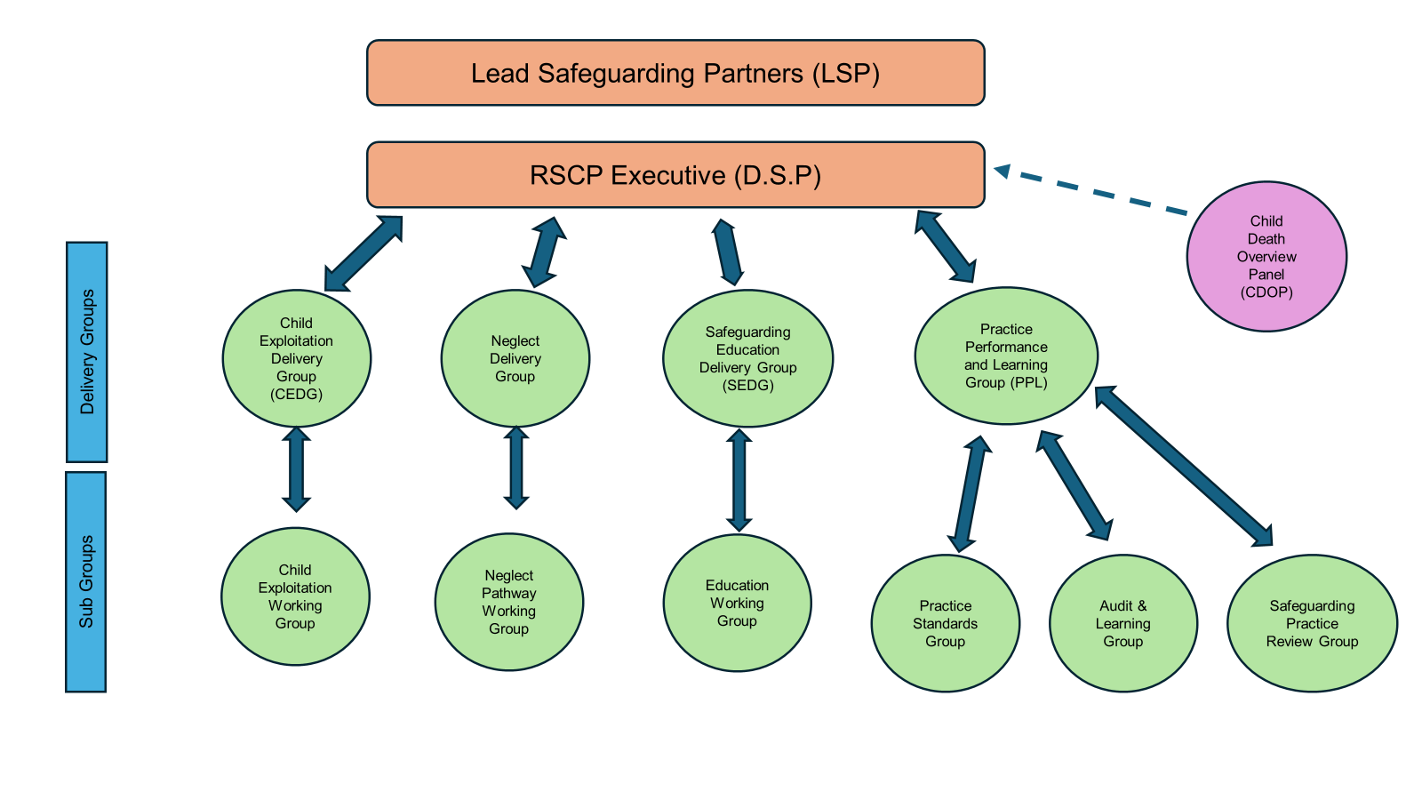

The Rotherham Safeguarding Children Partnership (RSCP) will continue to deliver the three-year plan running from 2023 – 2026. It will maintain an overarching remit in ensuring that children throughout Rotherham are Safe at Home, Safe in the Community and that Safe Systems exist to deliver excellent services. The RSCP will deliver against three key strategic priorities in this period.

The strategic priorities are:

* Neglect
* Safeguarding in Education
* Child Exploitation

The following coordination and delivery groups will have oversight of the partnership’s activities against these priorities:

* Child Exploitation Delivery Group Group (CEDG) - This is an established group with a 5-year strategic plan in place and will continue to work on the changing nature of exploitation and the challenges presented through online activity.
* Neglect Delivery Group (NeDG) - Neglect continues to be a significant factor in child protection and this group will prioritise early identification, prevention and multi-agency coordination in reducing harm.
* Safeguarding in Education Delivery Group (SEDG) - This group will continue to work to the identified priorities through the production of a strategy and comprehensive scorecard.
* Practice, Performance and Learning Delivery Group (PPLDG) – This group will continue to focus on ensuring practice improvements are delivered and that learning is communicated across the partnership. It will deliver the audit schedule and RSCP performance data, along with delivering the reviews required.